WORKSHEET 1 — Ice Cream Discount (if–else)
package hnu.org.examples;
import java.util.Scanner;
public class IceCreamDiscount {
public static void main(String[] args) {
System.out.println("Please enter your total purchase amount:");
Scanner sc = new Scanner(System.in);
double total = sc.nextDouble();
if (total >= 100) {
System.out.println("You get a free topping!");
} else {
System.out.println("No free topping this time!");
}
}
}
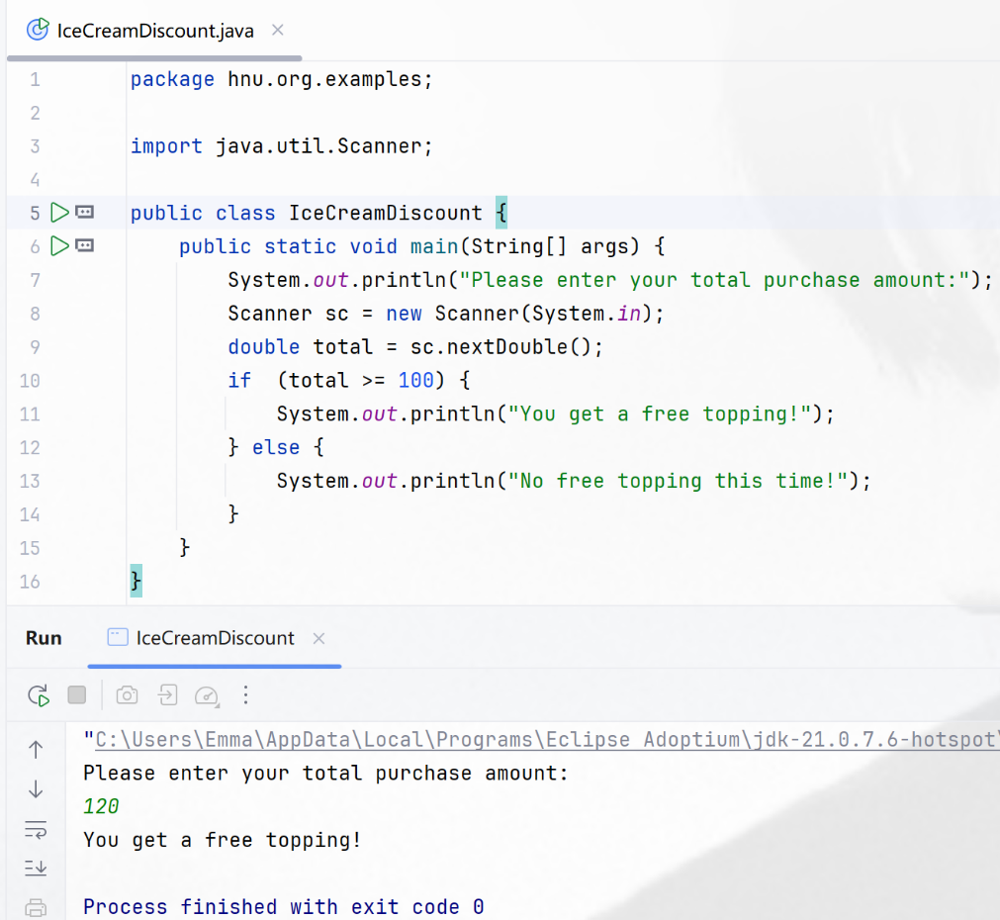

Questions:
- What input does the program take?
It takes a number (total) representing the total purchase amount entered by the user.

- What condition do you check?
Whether total purchase amount is greater than or equal to 100.

- When is the discount message displayed?
When the total purchase amount is greater than or equal to 100.

WORKSHEET 2 — Encapsulation: Read-Only Property
package hnu.org.examples;
class Student {
private int rollNumber;
public Student(int rollNumber) {
this.rollNumber = rollNumber;
} // constructor是对象生成时的一次性初始化，如果后续要修改属性值，只能通过getter()来实现
public int getRollNumber() {
return rollNumber;
}
}
public class ReadOnlyProperty {
public static void main(String[] args) {
Student student = new Student(101);
System.out.println("Roll Number: " + student.getRollNumber());
}
}

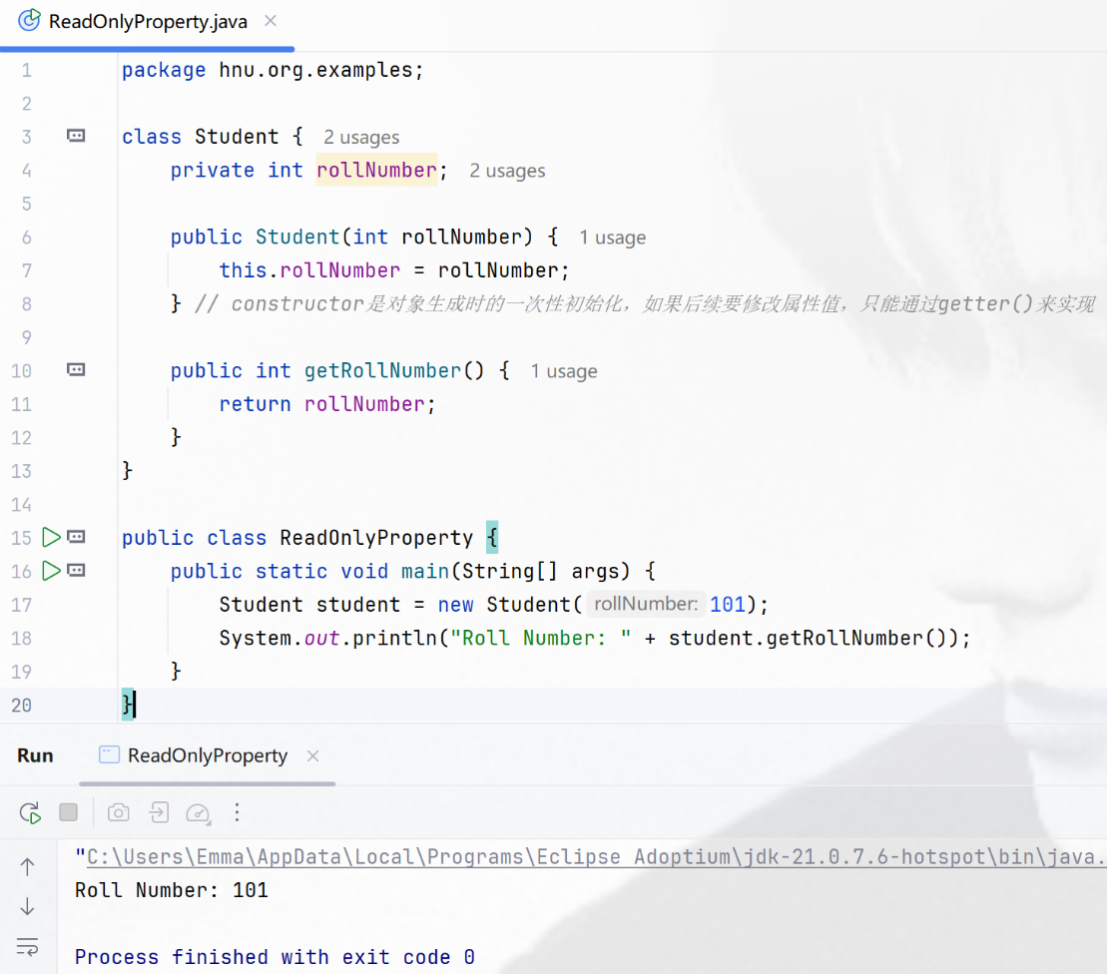

Questions:
- Why is the variable private?
To hide it from outside code (encapsulation). Only Student class can set its value by the constructor, others must use getter() method to get its value.

- What happens if no setter is provided?
The value can not change.

- Can the value be changed from main()?
No, main() can only get the value by getter() method but not change the value.

WORKSHEET 3 — Encapsulation: Write-Only Property
package hnu.org.examples;
class BankAccount {
private double balance;
public void setBalance(double balance) {
this.balance = balance;
System.out.println("Balance updated!");
}
}
public class WriteOnlyProperty {
public static void main(String[] args) {
BankAccount bankAccount = new BankAccount();
bankAccount.setBalance(10000.00);
}
}
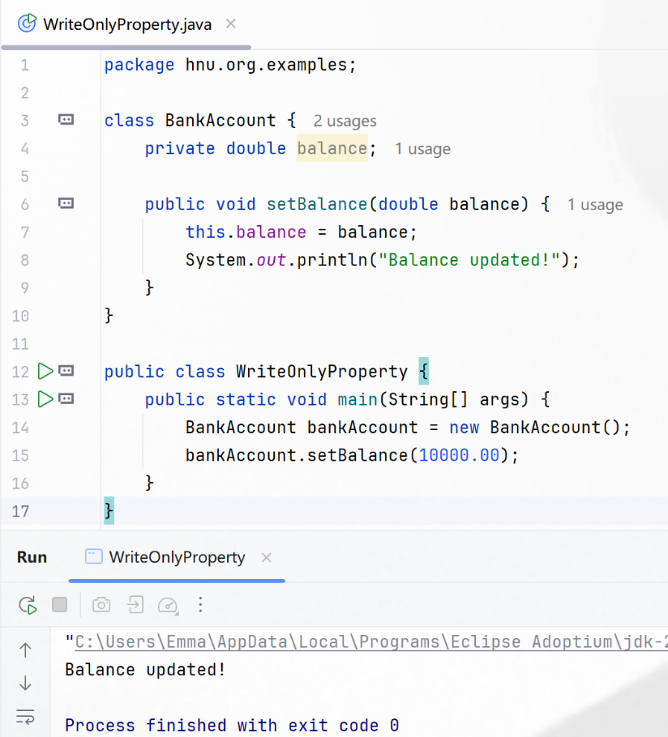

Questions:
- Why can the balance not be read?
Because balance is private and there is no getter() method.

- What is the use of write-only fields?
When we need to change the value but hide it for security at the same time.

WORKSHEET 4 — Inheritance (Single Inheritance)
package hnu.org.examples;
class Animal {
public void eat() {
System.out.println("Animal is eating...");
}
}
class Dog extends Animal {
public void bark() {
System.out.println("Dog is barking...");
}
}
public class SingleInheritance {
public static void main(String[] args) {
Dog dog = new Dog();
dog.eat();
dog.bark();
}
}

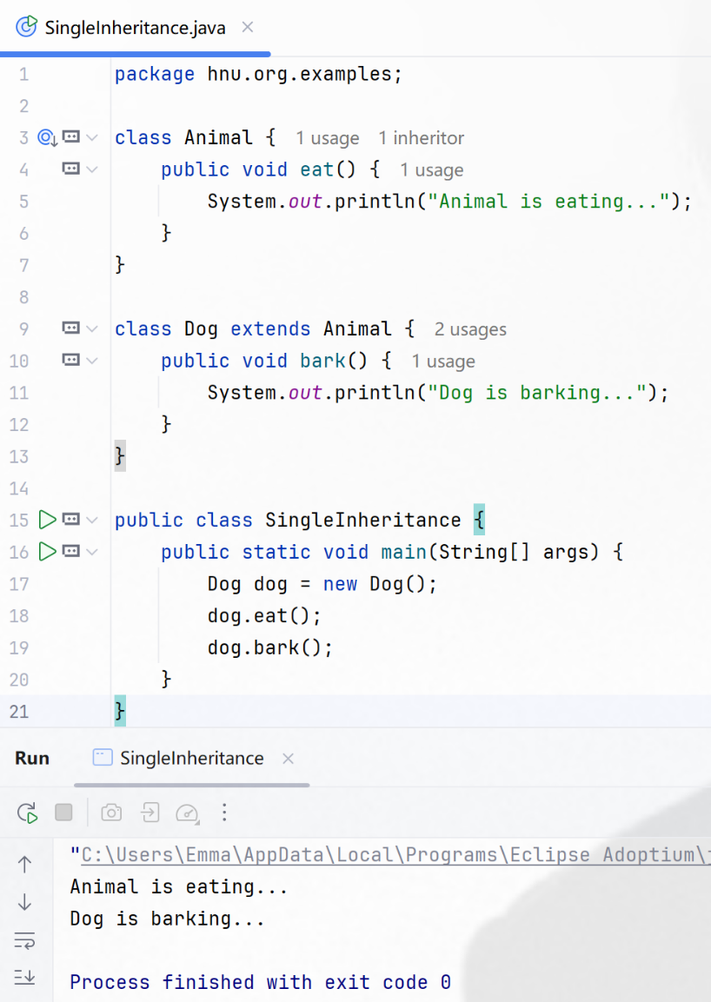

Questions:
- Which class is the parent?
The Animal class.

- Which class is the child?
The Dog class.

- What does Dog inherit?
Dog inherits the eat() method from Animal class.

WORKSHEET 5 — Dynamic Polymorphism (Method Overriding)
package hnu.org.examples;
class Vehicle {
public void move() {
System.out.println("Vehicle is starting smoothly...");
}
}
class Car extends Vehicle {
public void move() {
System.out.println("Car is starting smoothly...");
}
}
public class DynamicPolymorphism {
public static void main(String[] args) {
Car car = new Car();
car.move();
}
}

Questions:
- What is overriding?
Subclass provides a specific implementation of a method that is already defined in its superclass. In this case, the move() method in Car class overrides the one in Vehicle class.

- Which method executes at runtime?
The move() method in Car class.

- What reference type is used?
The reference type(引用类型) is Car.

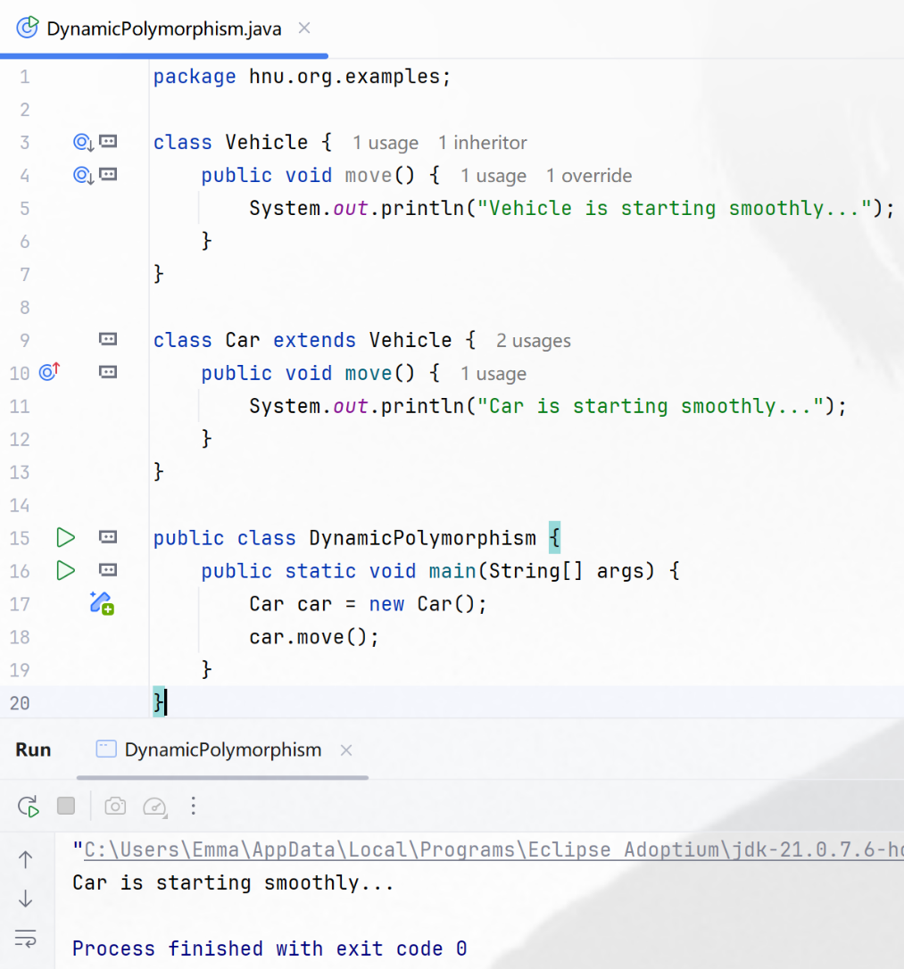

WORKSHEET 6 — Exception Handling (try–catch)
package hnu.org.examples;
public class ExceptionHandling {
public static void main(String[] args) {
try {
int a = 10;
int b = 0;
int c = a / b;
System.out.println(c);
} catch (ArithmeticException e) {
System.out.println("Error: " + e.getMessage());
}
}
}
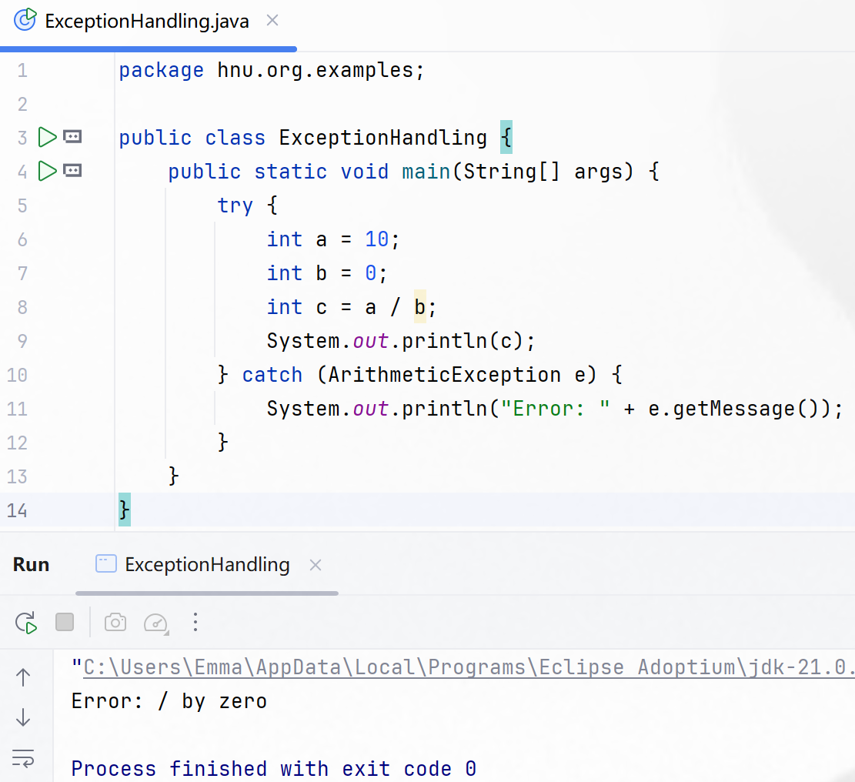

Questions:
- Which exception is thrown?
ArithmeticException, the exception message is “/ by zero”.

- Why does division by zero fail?
Because division by zero is undefined in arithmetic.

- What does catch do?
Intercepts the exception and executes its body (prints the error message).

WORKSHEET 7 — Checked vs Unchecked Exceptions
package hnu.org.examples;
import java.io.FileNotFoundException;
import java.io.FileReader;
public class UserDefinedException {
public static void main(String[] args) {
try {
int a = 10;
int b = 0;
int c = a / b;
System.out.println(c);
} catch (ArithmeticException e) {
System.out.println("Unchecked: ArithmeticException");
}
try {
FileReader fr = new FileReader("abc.txt");
System.out.println("文件打开成功！");
} catch (FileNotFoundException e) {
System.out.println("Checked: FileNotFoundException");
}
}
}

Questions:
- Which exception is checked?
Open abc.txt file.

- Is FileNotFoundException compile-time or runtime?
It happens in compile-time.

- Why must checked exceptions be handled?
Because the Java compiler forces all checked exceptions to be handled during the compile-time.

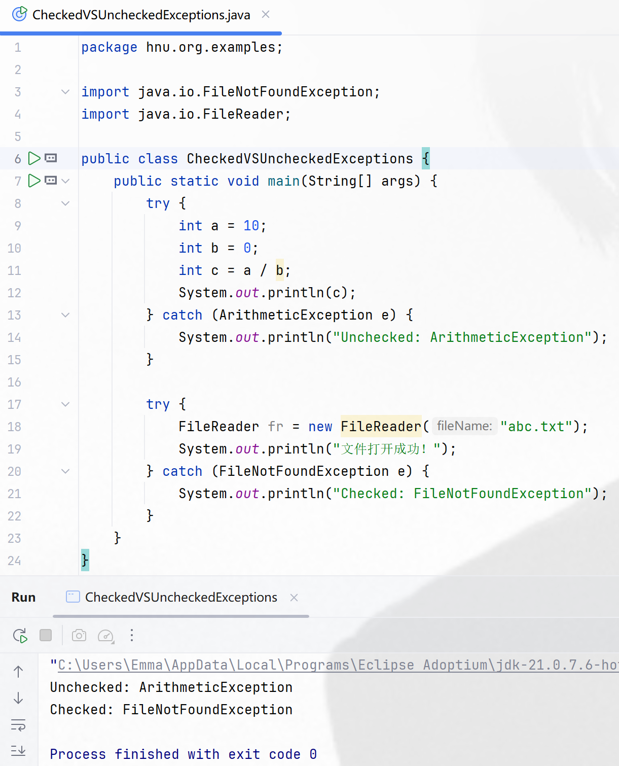

WORKSHEET 8 — User-Defined Exception
package hnu.org.examples;
public class UserDefinedException {
static class AgeException extends Exception {
public AgeException(String message) {
super(message);
}
}
public static void checkAge(int age) throws AgeException {
if (age < 18) {
throw new AgeException("Custom Exception: Age below 18 is not allowed!");
}
System.out.println("Age is valid.");
}
public static void main(String[] args) {
try {
checkAge(16);
} catch (AgeException e) {
System.out.println(e.getMessage());
}
}
}

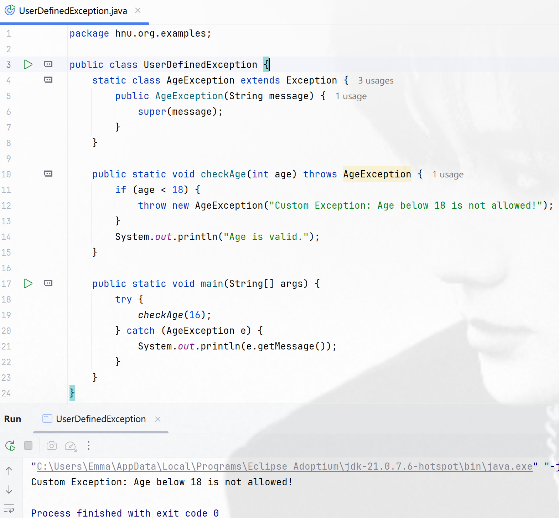

Questions:
- Why do we create custom exceptions?
To make the exception name easier to unserstand. For example, AgeException is easier to understand than Exception.

- How do we throw an exception?
Use the throw keyword and an instance exception. In this case, we use throw new AgeException("…");
- Where do we catch it?
In the try-catch block where you use that method.

